**GSM Module (SIM 808):**

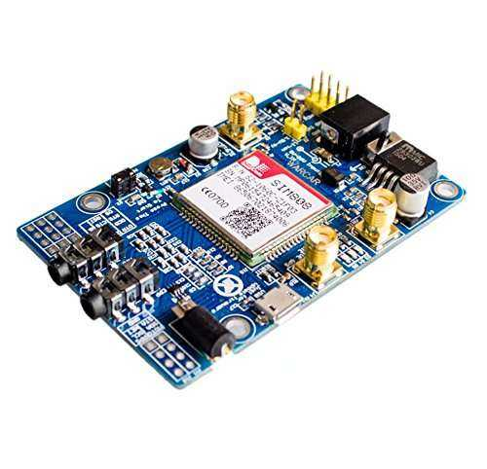

**Specification:**

* GSM &GPS & GPRS Integrated
* GPS accurancy 2.5 meter
* Supporting Freq Band 850/900/1800/1900
* Earphone/ microphone outputs on a card or external 32-ohm speaker + supports voice calls with an electret microphone.
* Sending and receiving GPRS data (TCP/IP, HTTP vb)
* UART communication with automatic baud rate settings.
* Support LED status indicator: Power supply status, network status, and operating modes
* support 2G/3G/4G SIM

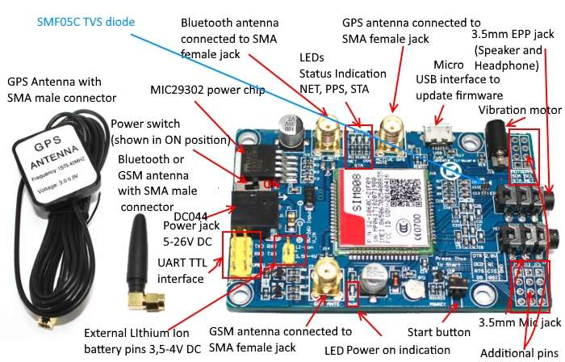

**Micro-Controller (Atmega 2560):**

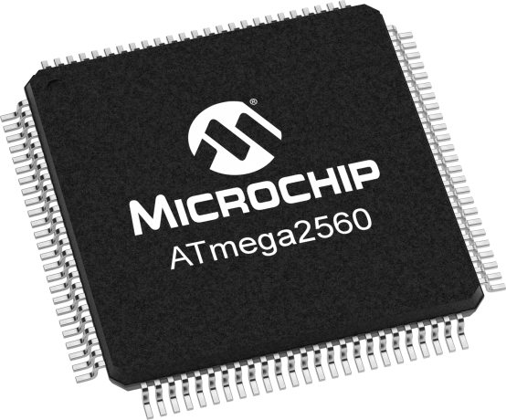

Specification:

* 256Kb programable flash Memory
* 4Kb EEPROM
* 8Kb Internal SRAM
* Two 8 bit Timer
* Four 16 bit Timer
* 8/16 channel 10bit ADC
* 2 Programmable UART
* Six Different Sleep Modes

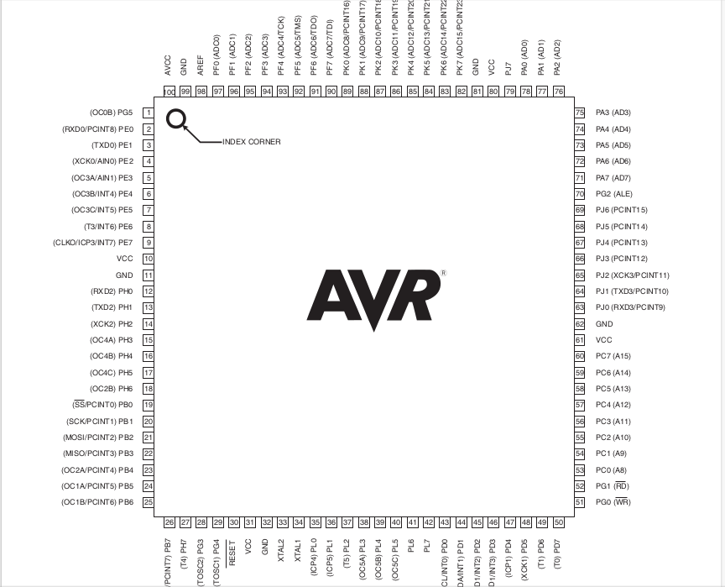S

******* Engg Board Specification Will be updated Once Board is Ready ******